OBJECT ORIENTED PROGRAMMING LAB MANUAL
NAME : ANISH BANSAL
ROLL NO. : R134218020
BRANCH : CSE CSF 2nd yr
BATCH : B1

Submitted To : SAURABH JAIN SIR

EXPERMENT 1
1. Installation of JDK.
Open Link:
http://www.oracle.com/technetwork/java/javase/downloads/jdk8-downloads-2133151.html
According to your system, configuration (64 bit/32 bit) /Operating System (Windows/Linux), download JDK.
For installation - Double click on exe file → click next→ next→………→Finish
Finally, we have completed the installation of jdk.

2. Setting of path variable (Temporary and Permanent).
Setting Temporary Path :
Copy the path of jdk/bin directory where java located
(C:\Program Files\Java\jdk1.8.0_131\bin)
Object Oriented Programming (CSEG2016)
Problem: OS is not able to recognize the .java file.
Solution 1: Setting Temporary Path :
Copy the path of jdk/bin directory where java located
(C:\Program Files\Java\jdk1.8.0_131\bin)
Write in the command prompt:
Note: In LINUX
export PATH=$PATH:/home/jdk1.6.01/bin
Again, compile the program:
After proper compilation, compiler will generate one intermediate code/byte code or .class file.
Execute the program: Java is the name java Interpreter
OR
Solution 2: Setting Permanent Path:
Go to My Computer properties → advanced tab → environment variables → new tab of user/system variable → write path in variable name → write path of bin folder in variable value → ok → ok → ok
If your program gets stuck in an infinite loop, type Ctrl-c to break out.

3. Introduction to Java IDE’s.
1. BlueJ
BlueJ Java IDE

Platform – Linux/macOS/Windows
First Released – March 1999

BlueJ is an integrated development environment for Java. Though mainly designed with educational intent, BlueJ is apt for small-scale software development. Despite being developed as a ready-to-go IDE for beginners, Java veterans widely prefer this Java IDE.

The primary screen of BlueJ displays the class structure of the application under development. It also allows for interactively creating and testing objects. The multi-platform Java IDE allows programmers to interact effortlessly with objects.

Developers can call methods on objects, inspect object values, and pass objects as parameters using the BlueJ Java IDE. Other powerful Java application development features offered by BlueJ include creating dynamic objects and scanning the code visually.

Features: (Blue J)

IDE interface
Runs on multiple platforms
Designed for teaching
Scope coloring
Runs without USB stick installation
Object bench
Supplementary BlueJ textbook
Portal of teaching resources
Interaction among objects
Code Pad
2. Codenvy
Codenvy Java IDEPlatform – Linux/macOS/Solaris/Windows
First Released – 2012

Codenvy is a commercial Java IDE built on top of the Eclipse Che. There are a total of 3 variants of the IDE that Java programmers can choose among; developer, enterprise, and team.

Codenvy is a cloud-based and on-demand developer workspace. In addition to writing Java code using the browser-based editor offered by Codenvy, Java programmers can benefit from powerful features like code completion, refactoring, and syntax highlighting.

The Codenvy editor also makes life easier for programmers by offering an effective way to build, debug, edit, and run various projects. The team edition of Codenvy aims at collaboration.

In addition to Java, Codenvy provides support for a plethora of interpreted as well as compiled programming languages; this includes C++, C#, JavaScript, and PHP.

Features:

Codenvy allows developers to:

Start a project in seconds, from any computer.
Work on-prem or in the cloud with an adaptable and well-paced IDE
Configure workspaces to include any stack using Dockerfiles.
Customize the IDE with Eclipse Che extensions and assemblies.
Launch parallel processes to build, run, and deploy.
Work online or offline with CLI push, pull, and clone.
3. DrJava
DrJavaPlatform – Linux/macOS/Windows
First Released – June 2002

Maintained by the JavaPLT group at Rice University, DrJava is a lightweight Java Integrated Development Environment. Specifically developed for beginners and students. Though not as powerful as other big names for Java development, DrJava has a remarkably clutter-free interface.

Other than offering a JUnit test facility, DrJava flaunts the ability to evaluate Java code from a console interactively as well as to present the output to the same console. Like its contemporaries, DrJava assists programmers with features like go to line and find/replace.

For advanced programmers, DrJava offers auto-completion, automatic indentation, brace matching, commenting, and syntax coloring. On top of all, DrJava integrates into Eclipse via a plugin.

DrJava, unlike other Java IDEs, has a consistent appearance on different platforms, this is because it is designed using Sun Microsystems’ Swing toolkit.

4. Eclipse
EclipsePlatform – Linux/macOS/Solaris/Windows
First Released – November 2001

A dedicated Java IDE, Eclipse gets listed as one of the big three of Java IDEs. The modern integrated development environment is available in both desktop and cloud editions. The cloud edition of the Eclipse, named Eclipse Che, allows programmers to develop apps via a web browser.

Both editions of the Eclipse IDE equips with required/additional functionality utilizing plugins. There is an array of plugins available for the IDE on the Eclipse Marketplace. To facilitate the incremental compilation of Java code, Eclipse comes with a custom compiler.

For Java programmers looking to develop specific functionality for Eclipse, a PDE (Plugin Development Environment) is available. To help Java developers hasten the application development, Eclipse flaunts powerful tools for charting, modeling, reporting, and testing.

Eclipse supports application development in several programming languages via plugins. C, C++, Clojure, Groovy, Haskell, JavaScript, Julia, Perl, PHP, Ruby, Rust, and Scala are some of the various programming languages supported by Eclipse.

Features:

a runtime core,
a collection of libraries,
a modeling and control language,
a development environment,
interfaces for embedding into host environments,
interfaces to third-party solvers.
5. Greenfoot
GreenfootPlatform – Linux/macOS/Solaris/Windows
First Released – 2003

Greenfoot is designed especially with an educational intent for high school and undergraduate students. The Java IDE facilitates the development of two-dimensional graphical apps, including simulations and interactive games.

Developed and maintained at King’s College London with support from Oracle, Greenfoot is an entirely free-to-use software. To motivate learning, Greenfoot offers easy access to animated graphics and sound.

Greenfoot’s interactive environment is designed to illustrate essential abstractions and concepts of object-oriented programming, including class/object relationship, methods, object interaction, and parameters.

Features:

Interactive Visual World
Simple Programming IDE
Real Java Code
Teacher Resources
Programmer Resources
Scope highlighting
New navigation view
Better Find and Replace
Code completion
Buil-in sound recorder
Mp3 support.
Debugger
Image editing
6. IntelliJ IDEA
IntelliJ IDEAPlatform – Linux/macOS/Windows
First Released – January 2001

IntelliJ IDEA is one of the big three of Java IDEs. It is available in 2 different editions, an Apache 2 Licensed community edition, and a proprietary commercial edition. To allow developers to dive deeper into the Java code, IntelliJ IDEA boasts cross-language refactoring and data flow analysis features.

Other features offered by IntelliJ IDEA that eases the life of a Java developer are chain completion, language injection, smart completion, and static member completion.

In addition to supporting Java and a galore of Java frameworks, IntelliJ IDEA also provides support for other JVM-based programming languages, such as Kotlin.

Features:

Smart completion
Chain completion
Static members completion
Data flow analysis
Language injection
Cross-language refactorings
Detecting duplicates
Inspections and quick-fixes

EXPERMENT 2
1.Write and execute my first java program.
public class Prin {
public static void main(String[] args )
{
System.out.println("My name is: Anish Bansal");
System.out.println("College name is: UPES");
System.out.println("Mobile no: 9888221231 Roll no is: R134218020");
}
}

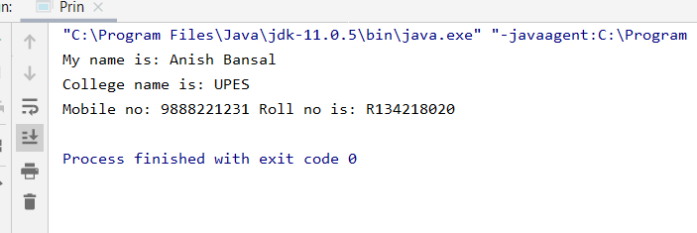
2. Write a program to print Fibonacci series using java loop.(up to 10 numbers)

import java.util.Scanner;
public class Prin{
public static void main(String[] args)
{
Scanner sca=new Scanner(System.in);
System.out.println("Enter the terms you want in FIBONACCI series");
int n=sca.nextInt();
int a=1;
int b=2;
if(n==1)
{
System.out.print(a+"\t");
}
else if(n==2)
System.out.print(a+"\t"+b+"\t");
else{
System.out.print(a+"\t"+b+"\t");
for(int i=0;i<n-2;i++)
{
int temp;
temp=b;
b=a+b;
a=temp;
System.out.print(b+"\t");
}
}
System.out.println("\nANISH BANSAL");
System.out.println("R.No-20");
}
}
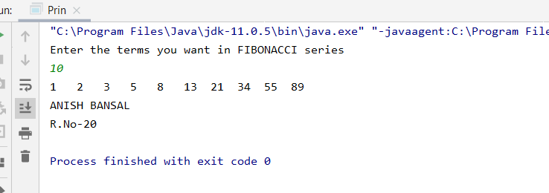

3. Write a program to find the largest of 3 numbers.
import java.util.Scanner;
public class Prin{
public static void main(String[] args)
{
Scanner sca=new Scanner(System.in);
System.out.println("Enter the value of a,b,c");
int a=sca.nextInt();
int b=sca.nextInt();
int c=sca.nextInt();
if(a>=b&&a>=c)
{
System.out.println("a is the largest number");
}
else if(b>=a&&b>=c)
System.out.println("b is the largest number");
else
System.out.println("c is the largest number");
System.out.println("ANISH BANSAL");
System.out.println("Roll.no=20");
sca.close();
}
}
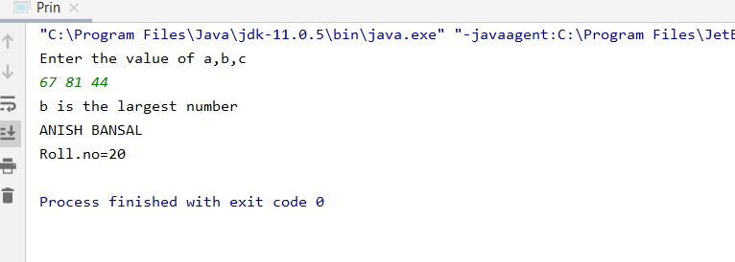
4. Write a program to find the sum of all integers greater than 40 and less than 250 that are divisible by 5.
public class Prin{
public static void main(String[] args)
{
int a=40;
int b=250;
int c=0;
for(int i=a+1;i<b;i++)
{
if(i%5==0)
c=i+c;
}
System.out.println("Sum of number which are divisible by 5 between 40 and 250 is "+c);
System.out.println("ANISH BANSAL");
System.out.println("Roll.no-20");
}
}

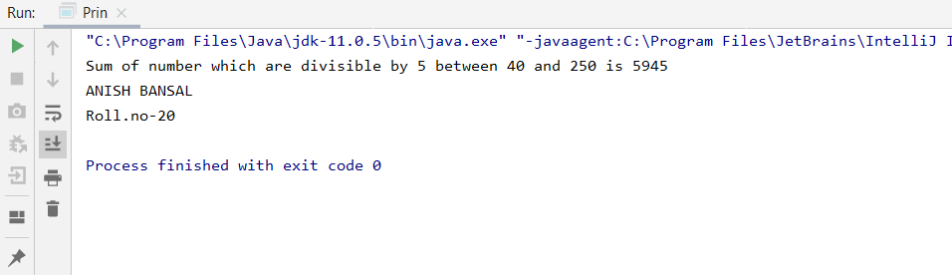

EXPERMENT 3
1. Write a program to input a number of a month (1 - 12) and print its equivalent name of the month.( e.g 1 to Jan, 2 to Feb. 12 to Dec.) Hint-use switch case
package com.company;
import java.util.Scanner;
public class Main {
public static void main(String[] args) {
Scanner s = new Scanner(System.in);
int no;
System.out.println("Enter the month number");
no = s.nextInt();
switch (no) {
case 1:
System.out.println("January");
break;
case 2:
System.out.println("Feburary");
break;
case 3:
System.out.println("March");
break;
case 4:
System.out.println("April");
break;
case 5:
System.out.println("May");
break;
case 6:
System.out.println("June");
break;
case 7:
System.out.println("July");
break;
case 8:
System.out.println("August");
break;
case 9:
System.out.println("September");
break;
case 10:
System.out.println("October");
break;
case 11:
System.out.println("November");
break;
case 12:
System.out.println("December");
break;
default:
System.out.println("invalid");
break;
}
}
}

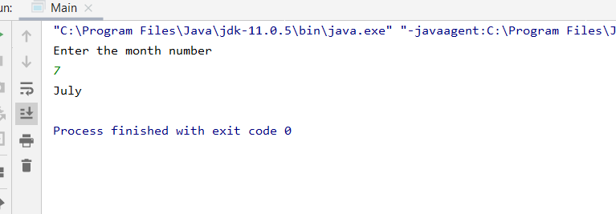

2. Write a program to add two number using command line arguments.

package com.company;
public class Main {
public static void main(String args[]) {
int a,b,c;
a=Integer.parseInt(args[0]);
b=Integer.parseInt(args[1]);
c=a+b;
System.out.println("Sum is "+c);
}
}

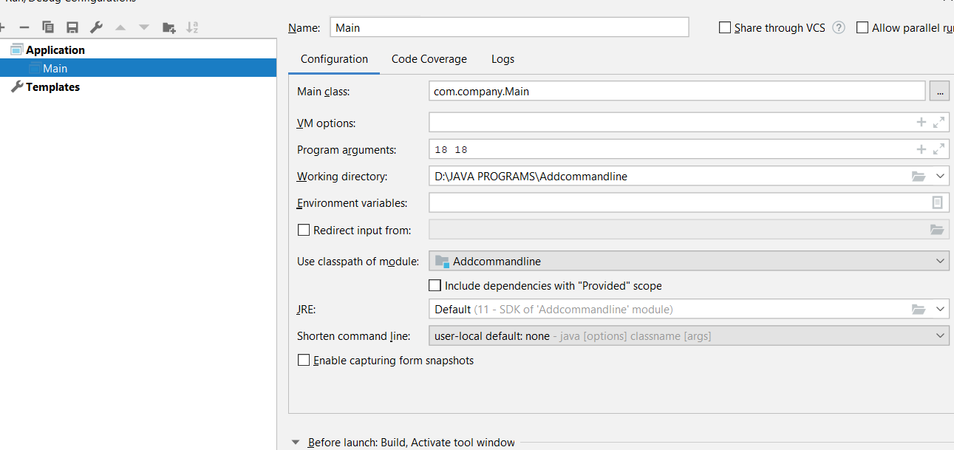

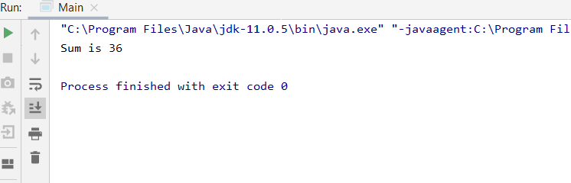

3. Write a program to implement a command line calculator.

public class Main {
public static void main(String args[]) {
int a, b, c;
a = Integer.parseInt(args[0]);
b = Integer.parseInt(args[1]);
c=a+b;
System.out.println("Sum is " + c);
c=a*b;
System.out.println("Product is " + c);
c=a-b;
System.out.println("Difference is " + c);
System.out.println("Division is " +(float)a/b);
System.out.println("ANISH BANSAL R.NO 20");
}
}

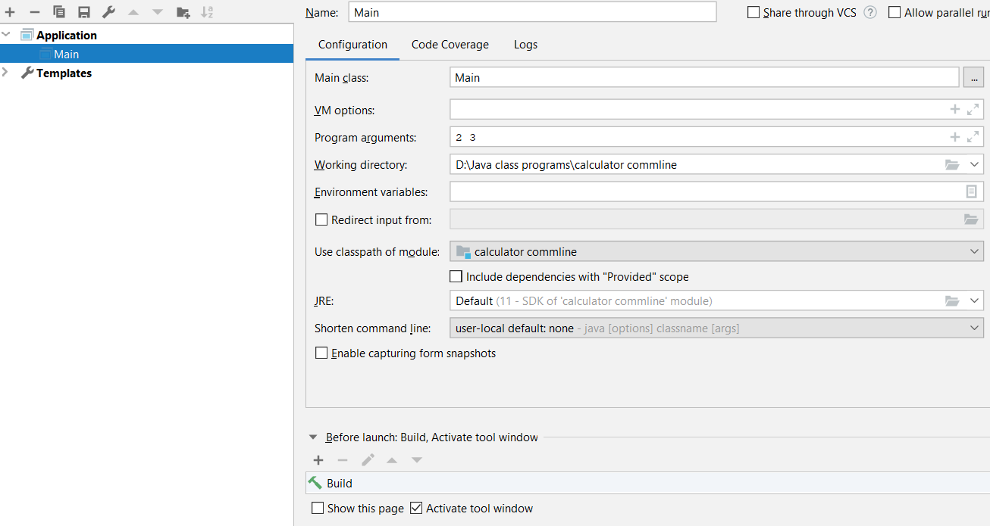

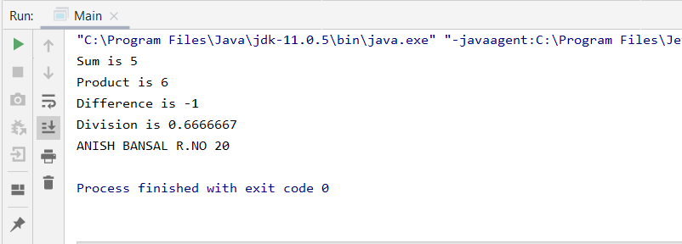

4. Write a program that takes student’s info from user(through Scanner class) and display on output screen. Use appropriate mutator and accessor. setInfo(),getInfo()

class Student1
{
int rollno;
String name;
double marks;
public void setData(int r,String s,double m){
rollno = r;
name = s;
marks = m;
}
public void getData(){
System.out.println("Roll no of the student: " +rollno);
System.out.println("Name of the student: " +name);
System.out.println("Marks of the student: " +marks);
}
}
public class Main
{
public static void main(String args[]){
Student1 s1 = new Student1();
s1.setData(20,"Anish",76.98);
s1.getData();
System.out.println();
Student1 s2 = new Student1();
s2.setData(4,"Akshay",98.7);
s2.getData();
System.out.println();
}
}

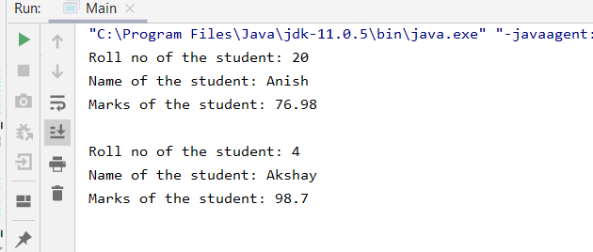

EXPERMENT 4

1. Write a JAVA program to implement class mechanism. – Create a class, methods and invoke them inside main method.

package anish;
public class Bank {
private int accNo;
private double balance;
private String name;
private String email;
private String PhNo;
public void setAccNo(int accNo) {
this.accNo = accNo;
}
public void setBalance(double balance) {
this.balance = balance;
}
public void setName(String name) {
this.name = name;
}
public void setEmail(String email) {
this.email = email;
}
public void setPhNo(String phNo) {
PhNo = phNo;
}
public double getBalance() {
return balance;
}
public int getAccNo() {
return accNo;
}
public String getPhNo() {
return PhNo;
}
public String getEmail() {
return email;
}
public String getName() {
return name;
}
public void depo(double balance)
{
this.balance=this.balance+balance;
System.out.println("YOUR BALANCE IS "+this.balance);
}
public void withdraw(double balance)
{
if(balance<this.balance)
this.balance=this.balance-balance;
else
System.out.println("INSUFFICIENT BALANCE");
System.out.println("YOUR BALANCE IS "+this.balance);
}
}

package anish;
public class Main {
public static void main(String[] args)
{
Bank b1 = new Bank();
b1.setAccNo(867665);
b1.setBalance(1000);
b1.setEmail("anishbansal231@gmail.com");
b1.setName("ANISH BANSAL");
b1.setPhNo("9888221231");
b1.depo(668);
System.out.println(b1.getBalance());
b1.withdraw(600);
System.out.println(b1.getBalance());
System.out.println("YOUR ACCOUNT NUMBER IS "+b1.getAccNo());
System.out.println("YOUR EMAIL IS "+b1.getEmail());
System.out.println("YOUR NAME IS "+b1.getName());
System.out.println("YOUR PHONE NO IS "+b1.getPhNo());
}
}

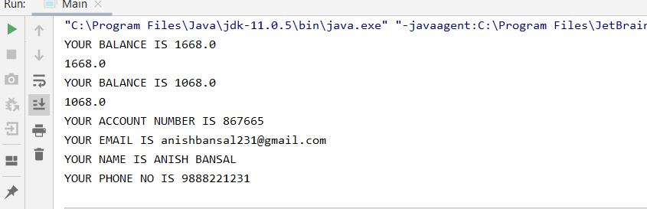
2. Write a JAVA program to implement compile time polymorphism.
package com.company;
public class Calculation {
void sum(int a,int b)
{
System.out.println(a+b);
}
void sum(int a,int b,int c)
{
System.out.println(a+b+c);
}
public static void main(String[] args) {
Calculation m=new Calculation();
m.sum(2,3);
m.sum(55,8,99);
}
}

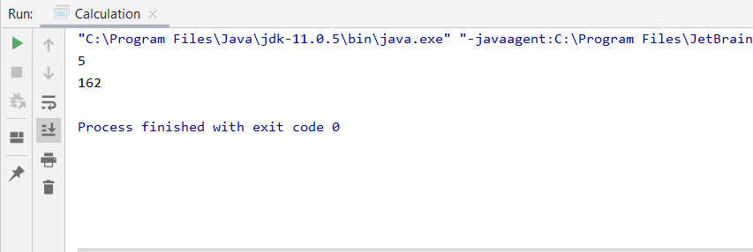

3. Write a JAVA program to implement type promotion in method overloading.
package com.company;
public class Calculation {
void sum(int a,int b)
{
System.out.println(a+b);
}
void sum(double a,double b)
{
System.out.println(a+b);
}
public static void main(String[] args) {
Calculation m=new Calculation();
m.sum(2,3);
int a=55;
float b=2.66f;
m.sum(55,2.66);
}
}

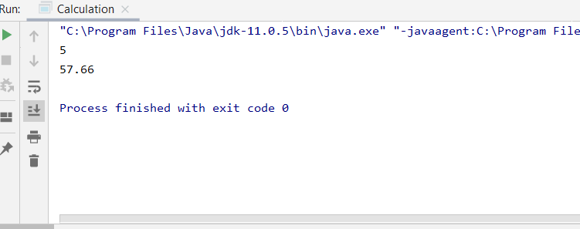
EXPERMENT 5
1. Write a Java program to show that private member of a super class cannot be accessed from derived classes.

class derived extends Base
{
private void inht()
{
System.out.println("Experiment 5 Question 1");
System.out.println(name);
}
}
class Base {
private String name;
public void set_name()
{
name="Anish"
}
}
public class Main{
public static void main(String[] args) {
derived d= new derived();
}
}
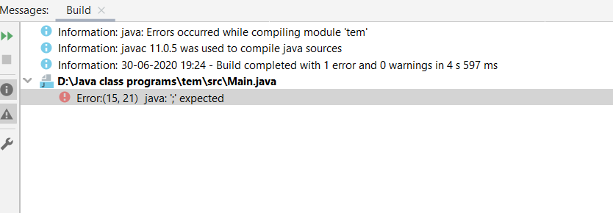

2. Write a program in Java to create a Player class. Inherit the classes Cricket _Player, Football _Player and Hockey_ Player from Player class.
class Cricket_Player extends Player
{
public void func1()
{
System.out.println("Cricket");
}
}
class Football_Player extends Player
{
public void func2()
{
System.out.println("Football");
}
}
class Hockey_Player extends Player
{
public void func3()
{
System.out.println("Hockey");
}
}
public class Player {
public static void main(String[] args) {
Cricket_Player a = new Cricket_Player();
Football_Player b = new Football_Player();
Hockey_Player c = new Hockey_Player();
a.func1();
b.func2();
c.func3();
System.out.println("ANISH BANSAL R.NO 20");
}
}

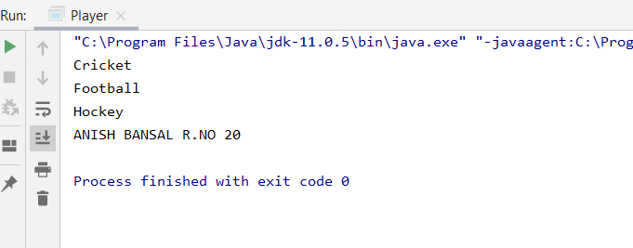

3. Write a class Worker and derive classes DailyWorker and SalariedWorker from it. Every worker has a name and a salary rate. Write method ComPay (int hours) to compute the week pay of every worker. A Daily Worker is paid on the basis of the number of days he/she works. The Salaried Worker gets paid the wage for 40 hours a week no matter what the actual hours are. Test this program to calculate the pay of workers. You are expected to use the concept of polymorphism to write this program
import java.util.Scanner;
class Worker
{
Scanner sc=new Scanner(System.in);
String name;
int salary_rate=10;
int salary;
void ComPay(int hours)
{
salary = salary_rate*hours;
System.out.println("salary of worker: "+salary);
}
}
class DailyWorker extends Worker
{
int days;
void getInfo(){
System.out.println("name: ");
name=sc.next();
System.out.println("no. of days worked:");
days =sc.nextInt();
System.out.println( name );
}
void ComPay()
{
salary= salary_rate*days;
System.out.println("salary of daily worker: "+salary);
}
}
class SalariedWorker extends Worker
{
void getInfo(){
System.out.println("name: ");
name=sc.next();
}
}
public class Main
{
public static void main(String args[]){
System.out.println("ANISH BANSAL R.No 20");
DailyWorker d= new DailyWorker();
d.getInfo();
d.ComPay();
SalariedWorker s=new SalariedWorker();
s.getInfo();
s.ComPay(40);
}
}

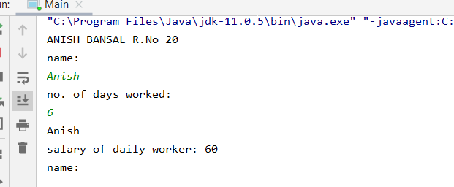

4. Design a class employee of an organization. An employee has a name, empid, and salary. Write the default constructor, a constructor with parameters (name, empid, and salary) and methods to return name and salary. Also write a method increaseSalary that raises the employee’s salary by a certain user specified percentage. Derive a subclass Manager from employee. Supply a test program that uses theses classes and methods.

import java.util.Scanner;
class Employee
{
Scanner sc=new Scanner(System.in);
String name;
int empid;
int salary;
Employee()
{
name= "justin";
salary= 50000;
System.out.println("name: "+name+"\n"+"salary: "+salary);
}
Employee(String n,int id,int s)
{
name=n;
empid=id;
salary=s;
System.out.println("name: "+name+ "\n"+"salary: "+salary);
}
void increase()
{
int inc;
System.out.println("enter the increase amount: ");
inc=sc.nextInt();
System.out.println("salary after increase:"+(salary+inc));
}
}
class Manager extends Employee
{
Manager(){
super("Jonathan",101,70000);
}
}
public class Main
{
public static void main(String args[]){
System.out.println("ANISH BANSAL R.NO 20");
Manager M=new Manager();
}
}

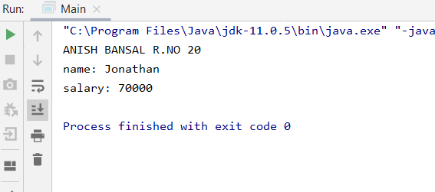

EXPERMENT 6
1. Write a program to create interface named test. In this interface the member function is square. Implement this interface in arithmetic class. Create one new class called ToTestInt. In this class use the object of arithmetic class.
interface myclass{
int square(int x);
}
class Arith implements myclass{
@Override
public int square(int x){
return x*x;
}
}
public class Main{
public static void main(String[] args) {
Test ob2= new Test();
ob2.answer(10);
System.out.println("ANISH BANSAL R.NO 20");
}
}
class Test {
void answer(int y){
Arith ob1=new Arith ();
System.out.println(ob1.square(y));
}
}

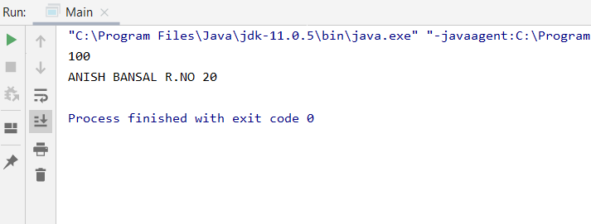

2. Write a program to create interface A, in this interface we have two method meth1 and meth2. Implements this interface in another class named MyClass.
interface A{
void method1();
void method2();
}
public class Main {
public static void main(String[] args){
xyz ob1 = new xyz();
ob1.method1();
ob1.method2();
System.out.println("ANISH BANSAL R.NO 20");
}
}
class xyz implements A{
public void method1(){
System.out.println("Method 1");
}
public void method2(){
System.out.println("Method 2");
}
}
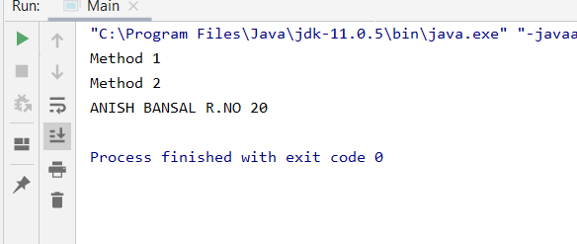

3. Implement Multiple and multilevel Inheritance using Interface.
public class Main {
public static void main(String[] args) {
A a= new A();
a.meth1();
B b= new B();
b.meth1();
b.meth2();
D d= new D();
d.meth1();
d.meth2();
C c= new C();
c.metha();
c.methb();
System.out.println("ANISH BANSAL R.NO 20");
}
}
class A {
public void meth1()
{
System.out.println("METHOD 1");
}
}
class B extends A{
public void meth2()
{
System.out.println("METHOD 2");
}
@Override
public void meth1() {
System.out.println("Method 1 in class B");
}
}
class D extends B{
@Override
public void meth1() {
System.out.println("Method 1 is present in class D");
}
public void meth2() {
System.out.println("Method 2 is present in class D");
}
}
interface I1
{
public void metha();
}
interface I2
{
public void methb();
}
class C implements I1,I2
{
@Override
public void metha() {
System.out.println("method a in class C");
}
@Override
public void methb() {
System.out.println("method b in class C");
}
}
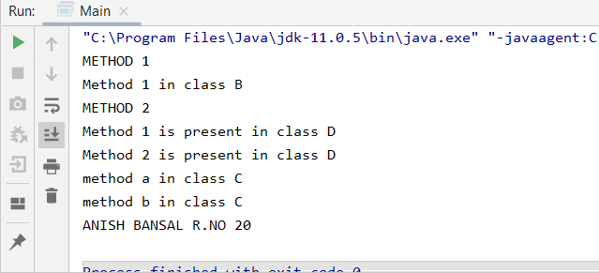

4. Write a program to create an Interface having two methods division and modules. Create a class, which overrides these methods.
public class Main {
public static void main(String[] args){
class4 x= new class4();
x.module(11,4);
x.div(11,4);
System.out.println("ANISH BANSAL R.NO 20");
}
}
interface class3{
void module(int y, int z);
void div(int c , int d);
}
class class4 implements class3{
@Override
public void module(int y, int z){
System.out.println(" The modulus is " + y%z);
}
@Override
public void div(int c, int d){
System.out.println(" The divison is " + (c/d));
}
}

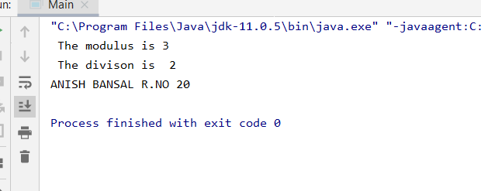
EXPERMENT 7

1. Write a Java program to implement the concept of importing classes from user defined package and created packages
Program:
Package:
package Sport;
public class Volleball
{
public void run(){

String name="hinata";
System.out.println(name+"is the little giant");
}
}
Main:
import Sport.Volleball;
class PV
{
public static void main(String args[])
{
Volleball V=new Volleball();
V.run();
}
}
Output:
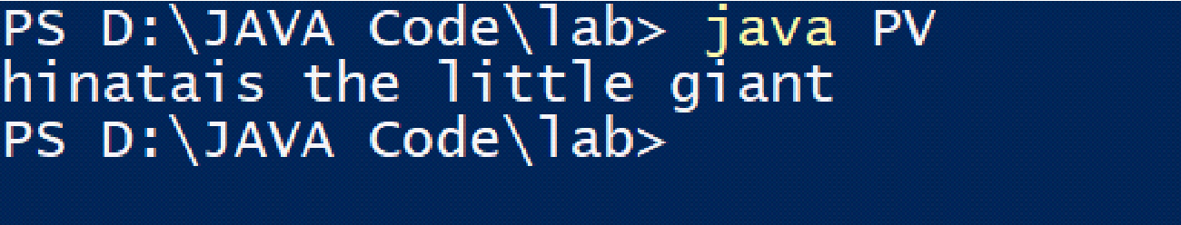
2. Write a program to make a package Balance. This has an Account class with Display_Balance method. Import Balance package in another program to access Display_Balance method of Account class.
Package:
package Balance;
public class Account
{
public void Display_balance()
{
int balance=10000;
System.out.println("balance: "+balance);
}
}
Program:
import Balance.Account;
class Display
{
public static void main(String args[])
{
Account customer= new Account();
customer.Display_balance();
}
}
Output:
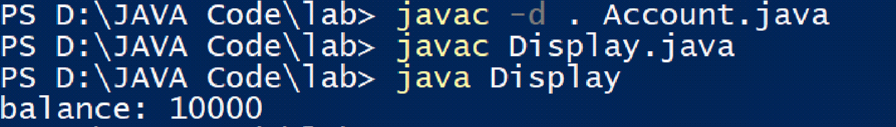

3. Write a java program that creates a package calculation. Add following classes in it:
a) Addition
b) Subtraction
c) Division
d) Multiplication
Write another Test class, import and use the above package.
Package:
Package calculation
public class Addition{
Addition(int a,int b){
System.out.println(a+b);
}
}
public class Subtraction{
Subtraction(int a,int b){
System.out.println(a-b);
}
}
public class Multiply{
Multiply(int a,int b){
System.out.println(a*b);
}
}
public class Division{
Division(int a,int b){
System.out.println(a/b);
}
}

Program:
import calculation.Addition;
import calculation.Subtraction;
import calculation.Division;
import calculation.Multiply;
class ASDM
{
public static void main(String args[])
{
Addition A=new Addition(10,5);
Subtraction s=new Subtraction(5,3);
Division d=new Division(15,3);
Multiply m=new Multiply(4,5);
}
}
Output:
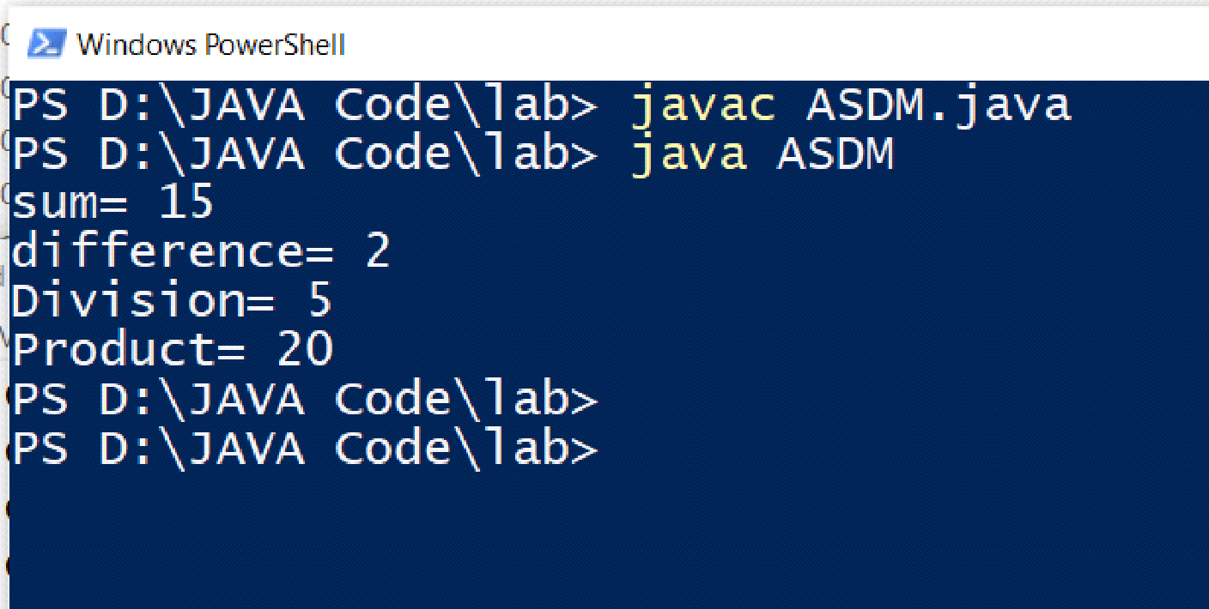

EXPERMENT 8

- Write a program in Java to display the names and roll numbers of students. Initialize respective array variables for 10 students. Handle ArrayIndexOutOfBoundsExeption, so that any such problem doesn’t cause illegal termination of program.

public class Main {
public static void main(String[] args) {
Students s1 = new Students();
try {
s1.add("Anish", 1);
s1.add("Anish", 2);
s1.add("Anish", 3);
s1.add("Anish", 4);
s1.add("Anish", 5);
s1.add("Anish", 6);
s1.add("Anish", 7);
s1.add("Anish", 8);
s1.add("Anish", 9);
s1.add("Anish", 10);
s1.add("Anish", 11);
} catch (ArrayIndexOutOfBoundsException e) {
System.out.println("Entry 11 can not be inserted as Total number of entries allowed is 10");
}
String[] name = new String[10];
Integer[] rollno = new Integer[10];
name = s1.getName();
rollno = s1.getRollNo();
System.out.println("List of student is");
for(int i=0;i<10;i++)
{
System.out.println(name[i] + " roll no "+ rollno[i]);
}
System.out.println("NAME: ANISH BANSAL ROLL NO 20");
}
}

class Students {
private int TotalNo;
private int ma=10;
private String[] name=new String[ma];
private Integer[] rollNo=new Integer[ma];
public Students() {
TotalNo=0;
}
public void add(String name,int rno)
{
this.name[TotalNo]=name;
this.rollNo[TotalNo]=rno;
TotalNo++;
}
public String[] getName() {
return name;
}
public Integer[] getRollNo() {
return rollNo;
}
}

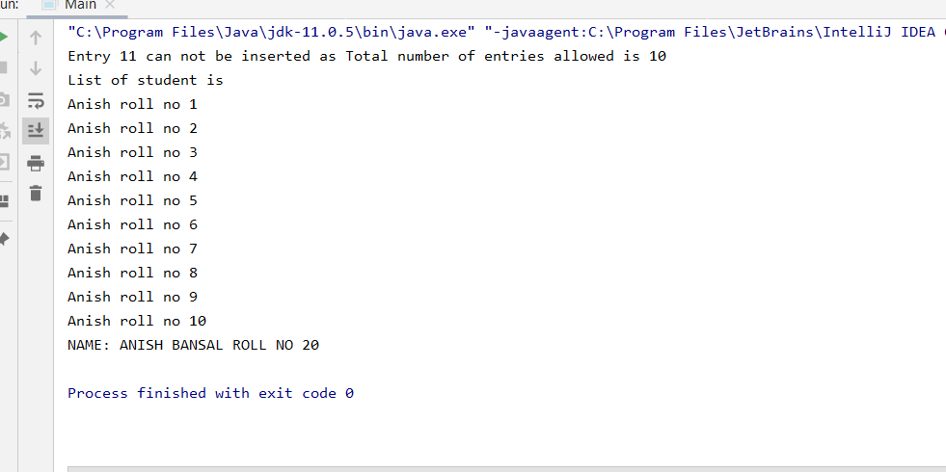

- Write a Java program to enable the user to handle any chance of divide by zero exception.

import java.util.Scanner;
public class Main {
public static double divide(int n1, int n2)
{
double ans;
ans=n1/n2;
return ans;
}
public static void main(String[] args)
{
System.out.println("Enter the first number");
Scanner scan = new Scanner(System.in);
int n1,n2;
double ans;
n1 = scan.nextInt();
while (true) {
try {
System.out.println("Enter the second number");
n2 = scan.nextInt();
ans = divide(n1, n2);
System.out.println("answer is " + ans);
System.out.println("NAME: ANISH BANSAL ROLL NO 20");
return;
} catch (ArithmeticException e) {
System.out.println("Please enter non zero value for second number");
}
}
}
}

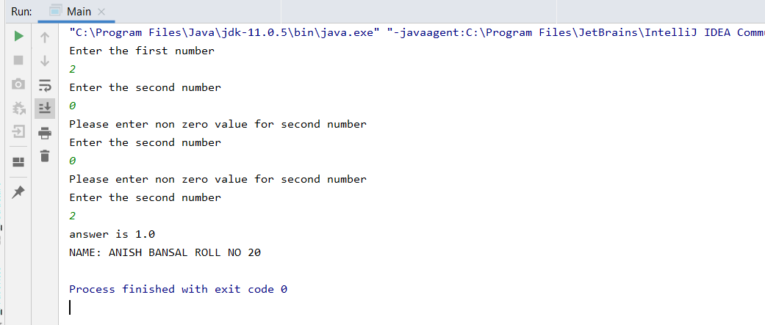

- Create an exception class, which throws an exception if operand is nonnumeric in calculating modules. (Use command line arguments).

public class Main {
static void comp(String x, String y) throws CustomException {
int flag=0,a=0,b=0;
try {
a = Integer.parseInt(x);
}
catch(NumberFormatException e)
{
flag=1;
}
try{
b = Integer.parseInt(y);
}
catch(NumberFormatException e)
{
flag=1;
}
if(flag==1)
throw new CustomException("nonnumeric value");
System.out.println("Addition is: " + (a + b));
System.out.println("Subtration is " + (a - b));
}
public static void main(String args[]) {
String x,y;
System.out.println("First Character:");
x = args[0];
System.out.println("Second Character:");
y = args[1];
try {
comp(x, y);
} catch (CustomException e) {
System.out.println(e);
}
System.out.println("NAME: ANISH BANSAL ROLL NO 20");
}
}

class CustomException extends Exception {
CustomException(String s1)
{
super(s1);
}
}
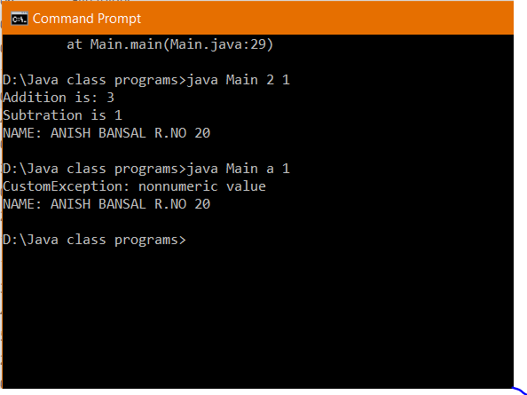

- Write a java program to throw an exception for an employee details.
- If an employee name is a number, a name exception must be thrown.
- If an employee age is greater than 50, an age exception must be thrown.
Or else an object must be created for the entered employee details

import java.util.Scanner;
public class Employee {
private String Name;
private int Age;
Employee(String Name,int Age)
{
this.Name=Name;
this.Age=Age;
System.out.println("Object for employee created");
}
static int flag=0;
static void checkage(int age) throws Exception {
if (age < 50) {
System.out.println("Eligible age");}
else {
throw new Exception("Not eligible age");}}
static void checkname(String name) throws Exception {
try {
int temp = Integer.parseInt(name);
flag=1;
}
catch(NumberFormatException a)
{
}
if(flag ==1)
throw new Exception("Name can not be numerical");
}
public static void main(String[] args)
{
System.out.println("Enter the age");
Scanner sca = new Scanner(System.in);
int age = sca.nextInt();
sca.nextLine();
System.out.println("Enter the name");
String name = sca.nextLine();
try{
checkage(age);
checkname(name);
Employee e1 = new Employee(name,age);
}
catch (Exception e) {
System.out.println(e);}
System.out.println("NAME: ANISH BANSAL ROLL NO 20");
}
}
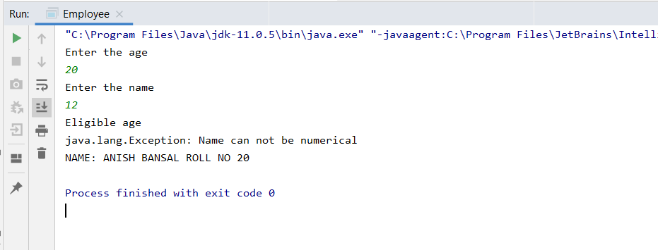

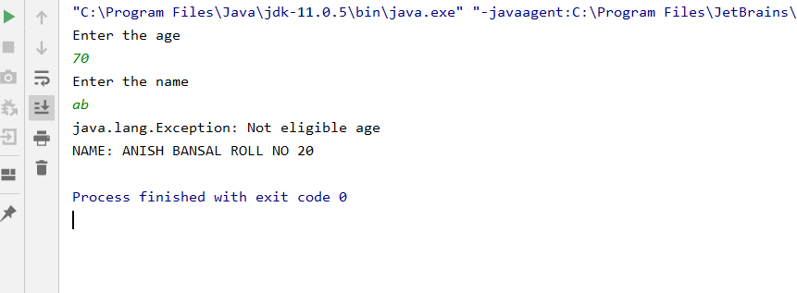

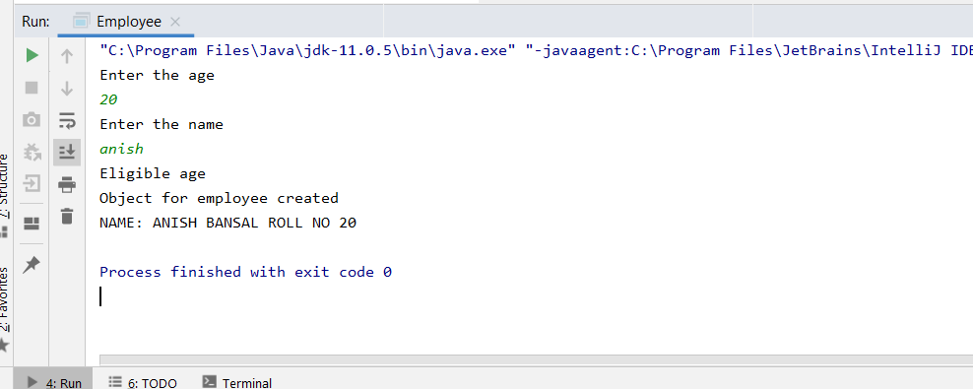

EXPERMENT 9
1) Write a program to implement the concept of threading by extending Thread Class and Runnable interface.

package anish;
public class Main {
public static void main(String[] args) {
System.out.println("Hello from the main thread.");
Thread anotherThread = new AnotherThread();
anotherThread.start();
System.out.println("Hello again from the main thread.");
System.out.println("ANISH BANSAL ROLL NO 20");
}
}

package anish;
public class AnotherThread extends Thread {
@Override
public void run() {
System.out.println( "Hello from another thread.");
}
}

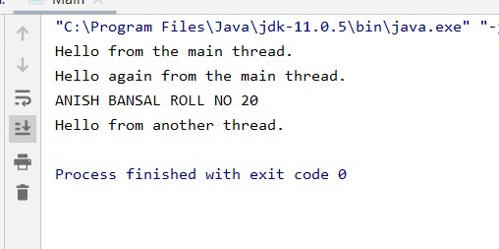

2) Write a program to implement the concept of threading by implementing Runnable interface.
package anish;
public class Main {
public static void main(String[] args) {
System.out.println("Hello from main thread");
Thread t1 = new Thread(new MyRunnable());
t1.start();
System.out.println("Hello again from the main thread.");
System.out.println("ANISH BANSAL ROLL NO 20");
}
}
class MyRunnable implements Runnable {
@Override
public void run() {
System.out.println("Hello from MyRunnable's implementation of run()");
}
}

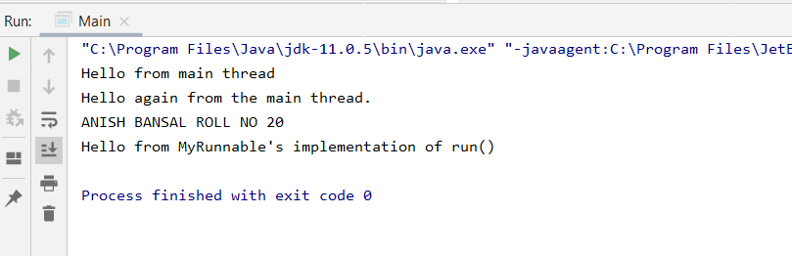
3) Write a program for generating 2 threads, one for printing even numbers and the other for printing odd numbers.

public class Ques3 {
public static void main(String[] args) {
Thread t1 = new Odd();
Thread t2 = new Even();
t1.start();
t2.start();
System.out.println("ANISH BANSAL ROLL NO 20");
}
}
class Odd extends Thread {
@Override
public void run() {
System.out.println("\nOdd Number:");
for (int i = 1; i <= 20; i += 2) {
System.out.print(" " + i);
}
}
}
class Even extends Thread {
@Override
public void run() {
System.out.println("\nEven Number:");
for (int i = 2; i <= 20; i += 2) {
System.out.print(" " + i);
}
}
}

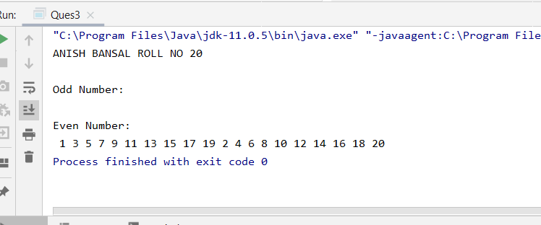

4) Write a Java program that implement multithreading among 3 threads. use sleep() and join() methods and show appropriate output
public class Main {
public static void main(String[] args) {
System.out.println("main thread is running");
Thread1 thr1= new Thread1();
thr1.start();
Thread thr2=new Thread(new Thread2()
{
public void run() {
System.out.println("thread2 is running ");
thr1.interrupt();
System.out.println("i(thread2) am awake after interrupting some other thread");
System.out.println("thread 2 ended");
}
});
thr2.start();
Thread thr3= new Thread(new Thread3(){
@Override
public void run() {
System.out.println("Thread3 is running");
try {
thr1.join();
}
catch(Exception e)
{
System.out.println("Unable to complete exection of Thread1");
}
System.out.println("thread 3 is running after completion of thread1");
System.out.println("thread3 ended");
}
});
thr3.start();
System.out.println("ANISH BANSAL R.NO 20");
System.out.println("main thread ended");
}
}
class Thread1 extends Thread{
@Override
public void run() {
System.out.println("This is Thread1");
try {
sleep(10);
}
catch (Exception e)
{
System.out.println("Thread1 is called by some other thread before 10 milli sec have passed");
}
System.out.println("10 milli sec have passed and i(thread1) am awake");
System.out.println("thread 1 ended");
}
}
abstract class Thread2 implements Runnable{
}
abstract class Thread3 implements Runnable{
}
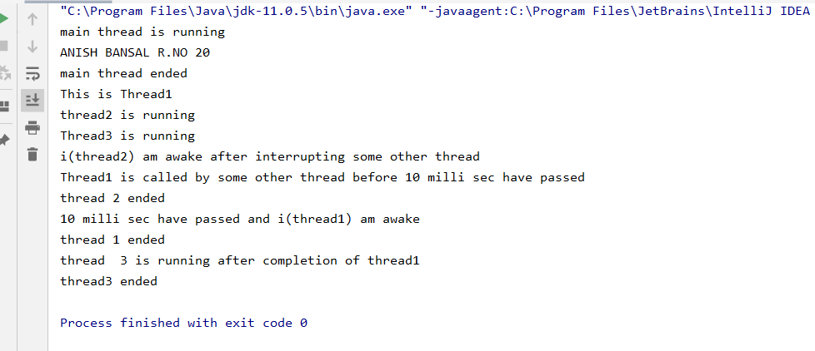
5) Write a Java program that show multithreading between three threads. Set different priority to each thread and show output.
import static java.lang.Thread.yield;
public class Main {
public static void main(String[] args) {
System.out.println("main thread is running");
Thread1 thr1= new Thread1();
thr1.setPriority(7);
thr1.start();
Thread thr2=new Thread(new Thread2()
{
public void run() {
System.out.println("thread2 is running ");
thr1.interrupt();
System.out.println("i(thread2) am awake after interrupting some other thread");
yield();
System.out.println("thread 2 ended");
}
});
thr2.setPriority(Thread.MIN_PRIORITY);
thr2.start();
Thread thr3= new Thread(new Thread3(){
@Override
public void run() {
System.out.println("Thread3 is running");
try {
thr1.join();
}
catch(Exception e)
{
System.out.println("Unable to complete exection of Thread1");
}
System.out.println("thread 3 is running after completion of thread1");
System.out.println("thread3 ended");
}
});
thr3.setPriority(4);
thr3.start();
System.out.println("ANISH BANSAL R.NO 20");
System.out.println("main thread ended");
}
}
class Thread1 extends Thread{
@Override
public void run() {
System.out.println("This is Thread1");
try {
sleep(10);
System.out.println("10 milli sec have passed and i(thread1) am awake");
}
catch (Exception e)
{
System.out.println("Thread1 is called by some other thread before 10 milli sec have passed");
}
System.out.println("thread 1 ended");
}
}
abstract class Thread2 implements Runnable{
}
abstract class Thread3 implements Runnable{
}
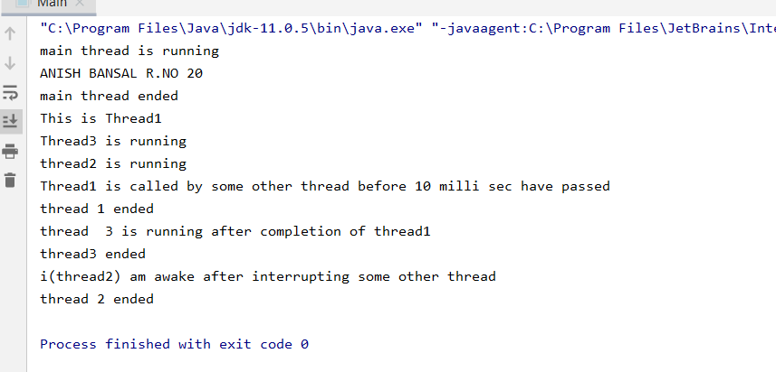

EXPERMENT 10
1. Write Java program using the following string methods:
• String concat(String str)
• boolean equals(Object anObject)
• boolean equalsIgnoreCase(String anotherString)
• String toUpperCase()
• char charAt(int index)
• int compareTo(String anotherString)

public class Stri {
public static void main(String args[]) {
String S1 = "Anish";
String S2 = "Bansal";
String s3 = S1.concat(S2);
System.out.println(s3);
String s1 = "Anish";
String s2 = "anish";
boolean b1 = s1.equals(s2);
if (b1)
System.out.println("s1 and s2 are equal");
else
System.out.println("s1 and s2 are different");
boolean b2 = s1.equalsIgnoreCase(s2);
if (b2)
System.out.println("s1 and s2 are equal(ignoring the case)");
else
System.out.println("s1 and s2 are different after ignoring case also");
String s4 = s2.toUpperCase();
System.out.println("String s2 is converted to upper case ie " + s2 + " to " + s4);
char c1 = s1.charAt(3);
System.out.println("3rd index of string " + s1 + " is " + c1);
String s5 = "address";
String s6 = "bill";
int i1 = s6.compareTo(s5);
System.out.println("value of i1 is " + i1 + " because compareTo function returned 1 because b is 1 greater then a in " + s5 + " and " + s6);
System.out.println("Name: Anish Bansal roll no 20");
}
}

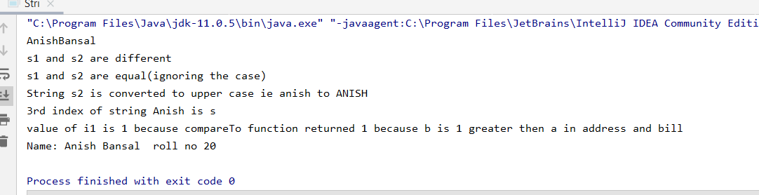

2. Write Java program using the following string methods:
• int hashCode()
• String trim()
• String intern()
• int length()
• String replace(char oldChar, char newChar)
• String substring(int beginIndex, int endIndex)

public class Stri {
public static void main(String[] args)
{
String s1="Table";
String s2="Chair";
System.out.println("hash codes of "+s1+" and "+s2+" are "+s1.hashCode()+" and "+s2.hashCode()+" respectively");
String s3=" Upes ";
String s4="dehradun";
System.out.println("Before using trim method in String UPES and displaying string dehradun after it gives result"+s3+s4);
System.out.println("After using trim method in String UPES and displaying string dehradun after it gives result"+s3.trim()+s4);
String s5=new String("hello");
String s6="hello";
String s7=s5.intern();
System.out.println(s5==s6);
System.out.println(s6==s7);
System.out.println("length of string " +s4+" is "+s4.length());
System.out.println("replacing d with h in the string "+s4+": "+s4.replace('d','h'));
String s2substr=s2.substring(2,5);
System.out.println(s2substr+" is subtring of "+s2);
System.out.println("Name: Anish Bansal roll no 20");
}
}

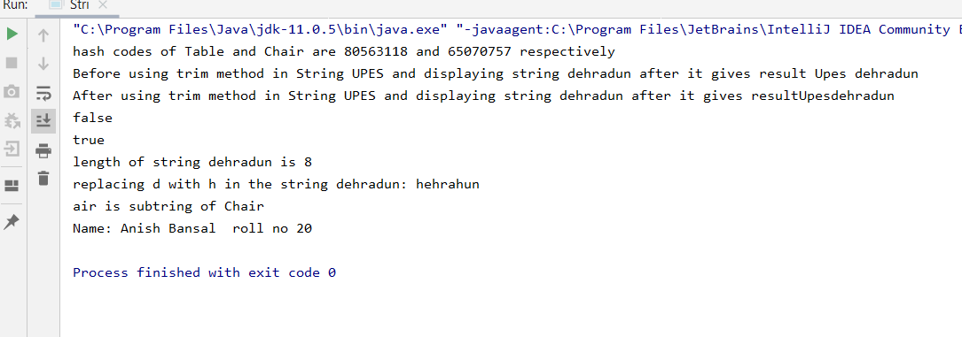

3.Write a Java code that converts int to Integer, converts Integer to String, converts String to int, converts int to String, converts String to Integer converts Integer to int.

public class Main {
public static void main(String[] args) {
int a=3;
Integer i=Integer.valueOf(a);
System.out.println(i);
String s=i.toString();
System.out.println(s);
int b=Integer.parseInt(s);
System.out.println(b);
String s2=String.valueOf(a);
System.out.println(s2);
Integer i2=Integer.valueOf(Integer.parseInt(s2));
System.out.println(i2);
int c=i.intValue();
System.out.println(c);
System.out.println("ANISH BANSAL R.NO 20");
}
}

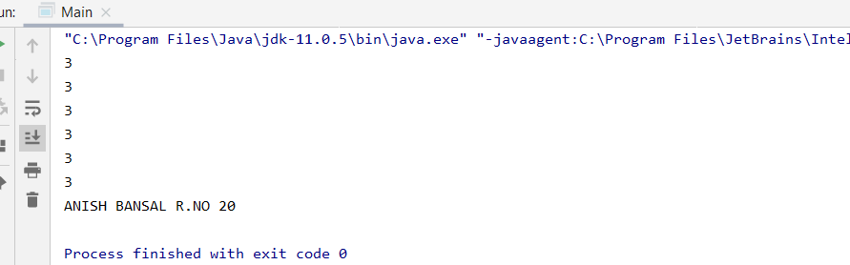

4.Write a Java code that converts float to Float converts Float to String converts String to float converts float to String converts String to Float converts Float to float.

public class Main {
public static void main(String[] args) {
float f=3.2f;
Float F=Float.valueOf(f);
System.out.println(F);
String S=F.toString();
System.out.println(S);
float f2=Float.parseFloat(S);
System.out.println(f2);
String S2=Float.valueOf(f2).toString();
System.out.println(S2);
Float F2=Float.valueOf(S2);
System.out.println(F2);
float f3= F2.floatValue();
System.out.println(f3);
System.out.println("ANISH BANSAL R.NO 20");
}
}

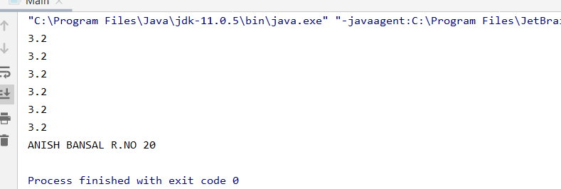

Experiment 11

1. Create a database table to store the records of employee in a company. Use getConnection function to connect the database. The statement object uses executeUpdate function to create a table.
Program:
import java.sql.*;
class TestJDBC
{
public static void main(String[] args) throws Exception
{ //1. Collect Database and Driver Info
String driverClassName = "com.mysql.jdbc.Driver";
String url="jdbc:mysql://localhost/mysql";
String user="root";
String pwd= "ROOT";//root
//2. Load JDBC Driver / Register a Driver
Class.forName(driverClassName).newInstance();
//3. Open a Connection
Connection con = DriverManager.getConnection(url,user,pwd);
System.out.println("con---->"+con);
//4. Create Statement and execute sql
Statement st = con.createStatement();
String sql= "INSERT INTO emp(name,salary) VALUE('ANISH',256856.05)" ;
st.executeUpdate(sql);
//5. close st and con : use finally block
st.close();
con.close();
System.out.println("---SQL executed successfully---");
}
}

2. Create a database of employee of company in mysql and then use java program to access the database for inserting information of employees in database. The SQL statement can be used to view the details of the data of employees in the database.
Program:
import java.sql.*;
import java.util.*;
import javax.swing.JOptionPane;
class company
{
public static void main(String[] args) throws Exception
{
Scanner sc = new Scanner(System.in);
Class.forName("com.mysql.jdbc.Driver").newInstance();
Connection con = DriverManager.getConnection("jdbc:mysql://localhost:3306/mysql?user=root&password=ROOT");
int k;
System.out.println("1.New Employee Record\n2.Delete Employee Record\n3.Employee Details");
System.out.print("Enter Your Choise:");
k = sc.nextInt();
switch(k)
{
case 1:
String n2=JOptionPane.showInputDialog("Enter Employee ID(100_):");
int ins1 = Integer.parseInt(n2);
String n=JOptionPane.showInputDialog("Enter Name:");
String s=JOptionPane.showInputDialog("Enter Salary:");
float fs=Float.parseFloat(s);
String sql = "INSERT INTO emp VALUE(?,?,?)";
PreparedStatement st = con.prepareStatement(sql);

st.setString(1,n2);
st.setString(2, n);
st.setFloat(3, fs);
st.executeUpdate();
st.close();
con.close();
break;
case 2:
String n1=JOptionPane.showInputDialog("Enter Employee ID(100_):");
int ins = Integer.parseInt(n1);
String sql1 = "delete from emp where Employee_ID =?";
PreparedStatement st1 = con.prepareStatement(sql1);

st1.setString(1, n1);
st1.executeUpdate();
st1.close();
con.close();
break;
case 3:
String n3=JOptionPane.showInputDialog("Enter Employee ID(100_):");
int ins2 = Integer.parseInt(n3);
String sql2 = "select * from emp where Employee_ID =?";
PreparedStatement st2 = con.prepareStatement(sql2);

st2.setString(1, n3);
ResultSet rs = st2.executeQuery();
System.out.println("Employee_ID"+"\t"+"Name"+"\t"+"Salary");
while (rs.next())
{
System.out.println(rs.getInt("Employee_Id")+"\t"+rs.getString("name")+"\t"+rs.getFloat("salary"));
}
rs.close();
st2.close();
con.close();
break;
default:
System.out.println("Wrong Choise");
break;
}
System.out.println("---SQL executed successfully---");
}
}

Experiment 12
1) Write a Servlet page to display current date of the server.
Program:
: Compile HelloServlet.java and place the .class file as the following
FirstApp > WEB-INF
> classes
> HelloServlet.class
> lib
> web.xml

Code:

web.xml HelloServlet.java
<web-app>  <servlet>  <servlet-name>ABC</servlet-name>  <servlet-class>HelloServlet</servlet-class>  </servlet>  <servlet-mapping>  <servlet-name>ABC</servlet-name>  <url-pattern>/abc</url-pattern>  </servlet-mapping>  </web-app> | import javax.servlet.*;  import javax.servlet.http.*;  import java.util.*;  import java.io.*;  public class HelloServlet extends HttpServlet  {  public void service(HttpServletRequest request, HttpServletResponse response)  throws IOException, ServletException  {  PrintWriter out = response.getWriter();  out.println("Welcome to Servlet : "+ new Date());  out.close();  }  }

Output:
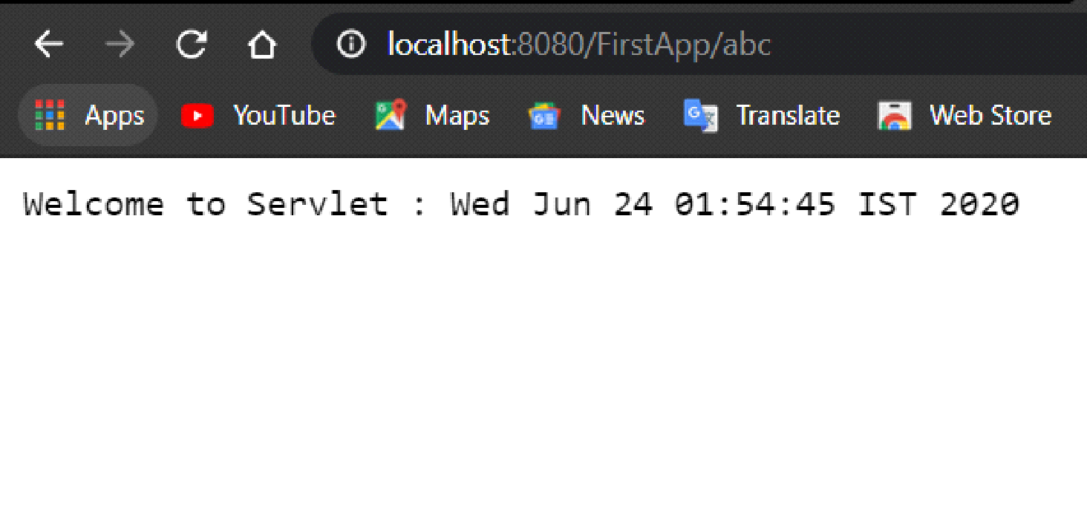

2) Write a JSP page that display the student information.
Program:
index.jsp
<%@ page import = "java.io.*,java.util.*,java.sql.*"%>
<%@ page import = "javax.servlet.http.*,javax.servlet.*" %>
<%@ taglib uri="http://java.sun.com/jsp/jstl/core" prefix="c" %>
<%@ taglib uri="http://java.sun.com/jsp/jstl/sql" prefix = "sql"%>

<html>
<head>
<title>CSE<title>
</head>
<body>
<h1 align="center"> Student information</h1>
<sql:setDataSource var = "snapshot" driver = "com.mysql.jdbc.Driver"
url = "jdbc:mysql://localhost/test"
user = "root" password = "1234" />

<sql:query dataSource = "${snapshot}" var = "result">
SELECT * from Student;
</sql:query>

<table align="center" border = "0" width="50%">
<tr>
<th style="text-align:center;"> name: </th>
<th style="text-align:center;"> roll no: </th>
</tr>
<c:forEach var = "row" items = "${result.rows}">
<tr>
<td style="text-align:center;"><c:out value = "${row.name}"/></td>
<td style="text-align:center;"><c:out value = "${row.roll}"/></td>
</tr></q></p>
</body>
</html>

web.xml
<web-app>

<welcome-file-list>
<welcome-file>index.jsp</welcome-file>
</welcome-file-list>

</web-app>

Output-
